36.64: a) As the rays first reach the slits there is already a phase difference between adjacent slits of 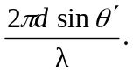
This, added to the usual phase difference introduced after passing through the slits, yields the condition for an intensity maximum:
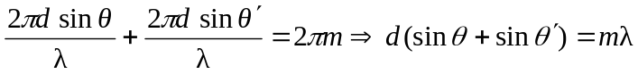
b) 600 